

Korenmolen / Windmolen
Aluminium / Carbon
Rollator Handleiding
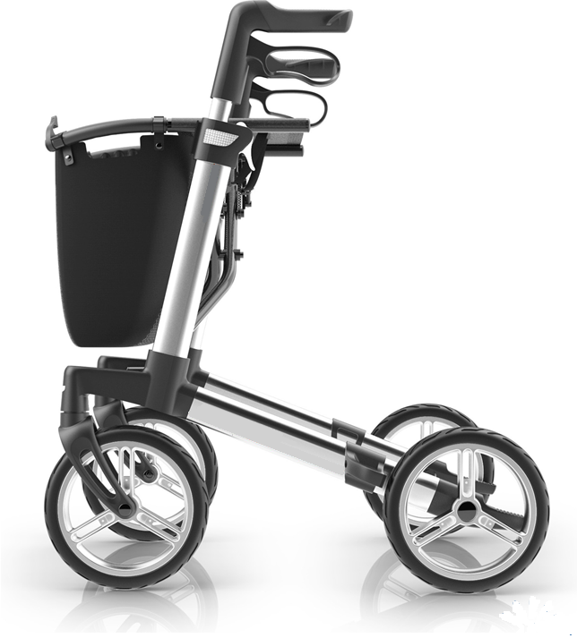

- Preface 2
  - Congratulations on your choice of Intco rollator 2
  - Important note 2
- Your product 3
- Before use 4
  - Upon delivery 4
  - Intended use 4
  - Safety instructions 4
  - Shipping and storage 5
- Before use 5
- Adjustment 6
  - Adjusting height 6
- Operation 7
  - Unfolding and folding 7
  - Brake system 8
  - Backrest belt 8
  - Shopping bag 8
  - Kerb lifter 9
  - Sitting down, standing up and walking 9
- Maintenance 10
  - Cleaning 10
  - Disinfection 10
  - Inspection / Service / Repairs 10
  - Reuse 10
  - Disposal at end of life 10
- Specifications 11
- Warranty 12

Congratulations on your choice of Intco rollator
Quality and functionality are keywords for all Intco Medical products. We are very keen to receive any feedback from you about your experiences of using this rollator. In this way we can produce an even better product.

For your own safety, and in order to derive the greatest benefit from the features of your new rollator, we recommend that you read this user manual carefully before you start to use the rollator.

If you still have questions after reading this manual, do not hesitate to contact your specialist dealer. He/she will be glad to help you.

Important note
To ensure your safety and to prolong the lifetime of your product, please take good care of it and have it checked and serviced on a regular basis.

This manual reflects the latest product developments. Intco has the right to implement changes to this type of product without any obligation to adapt or replace similar products previously delivered.

Pictures of the product are used to clarify the instructions in this manual. Details of the depicted product may deviate from your product.
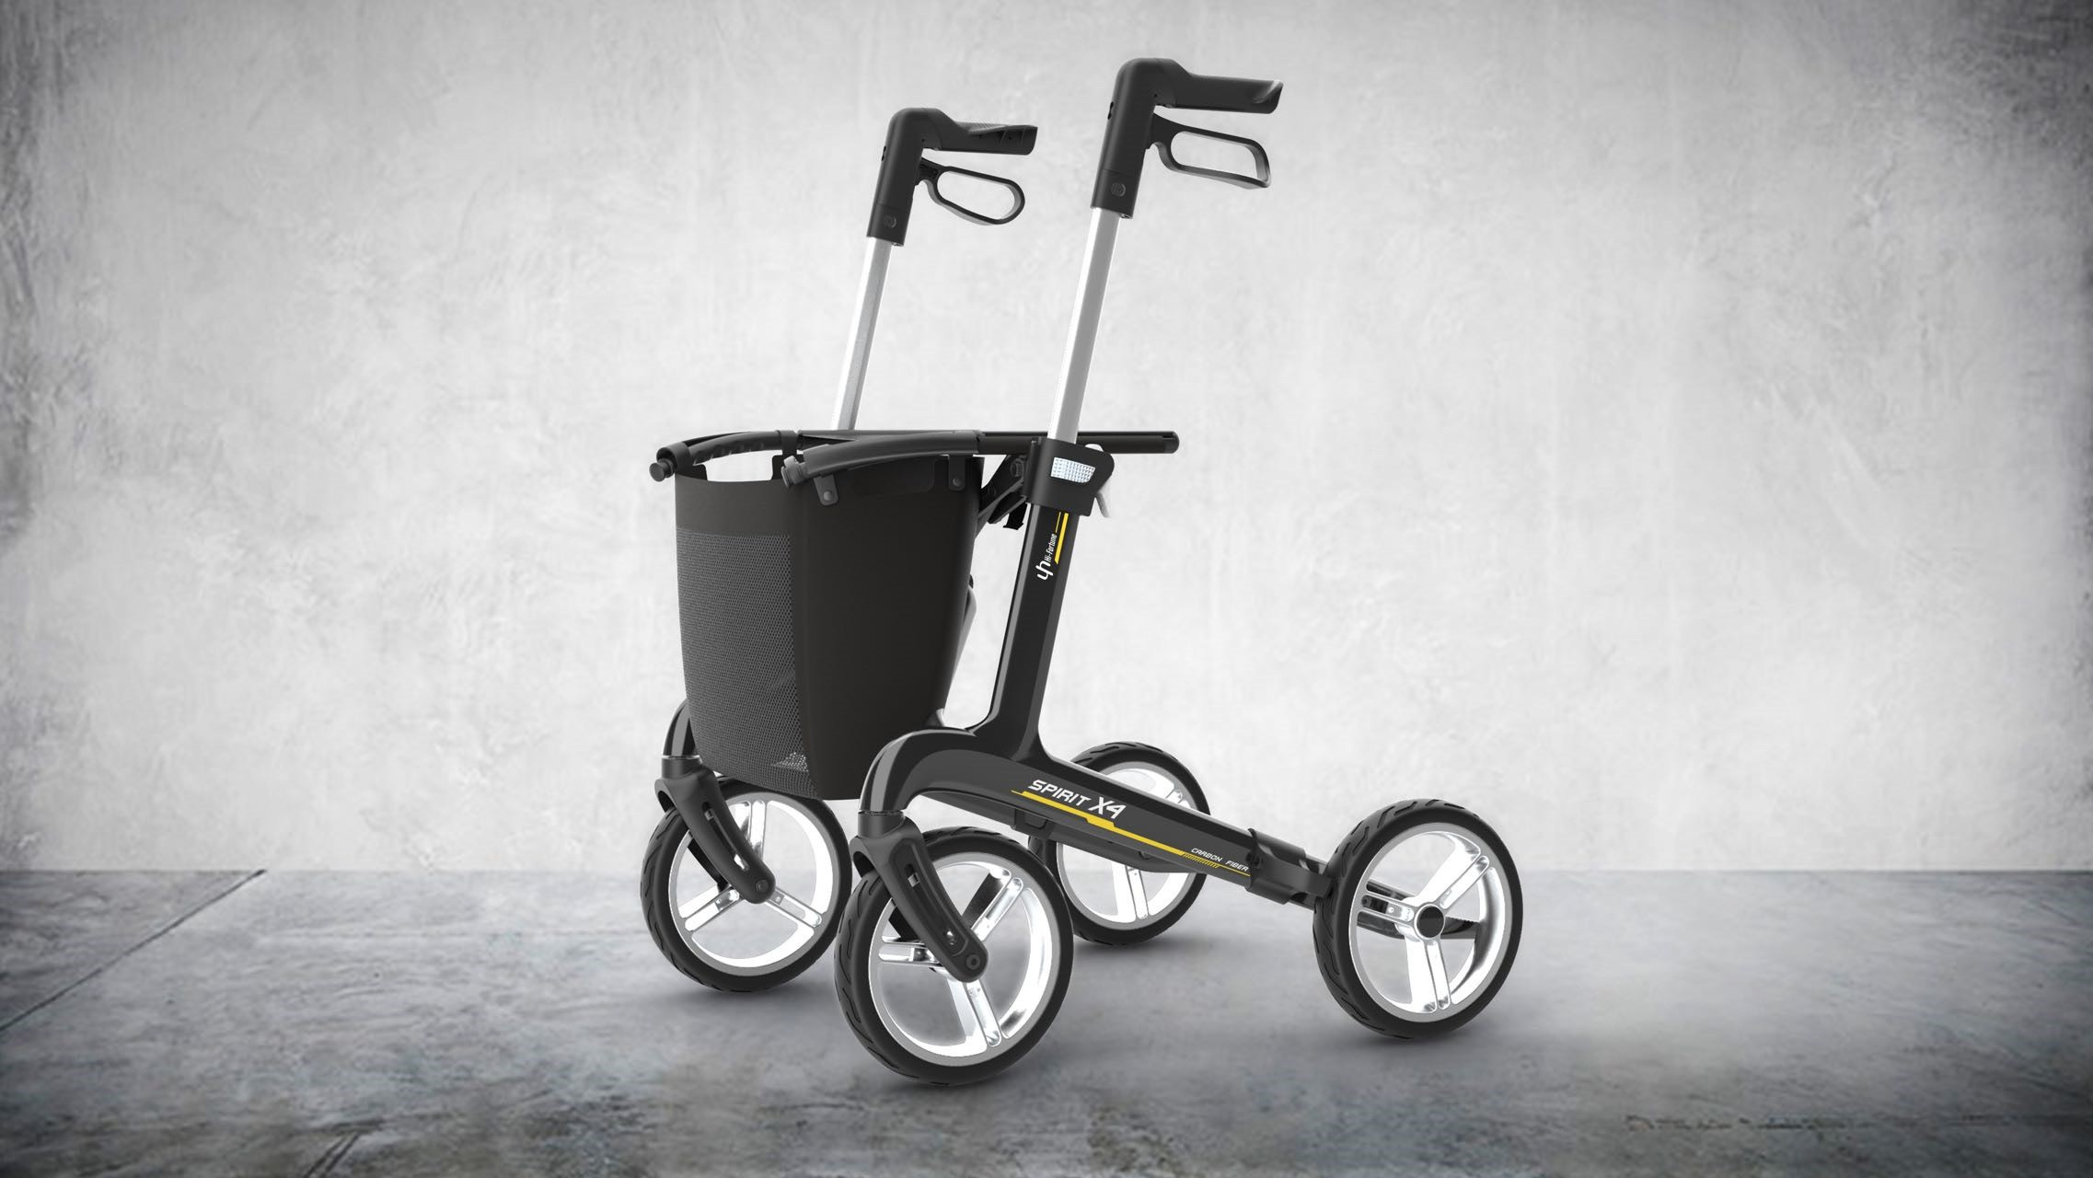
Figure 1. Spirit X4 Rollator (Carbon)

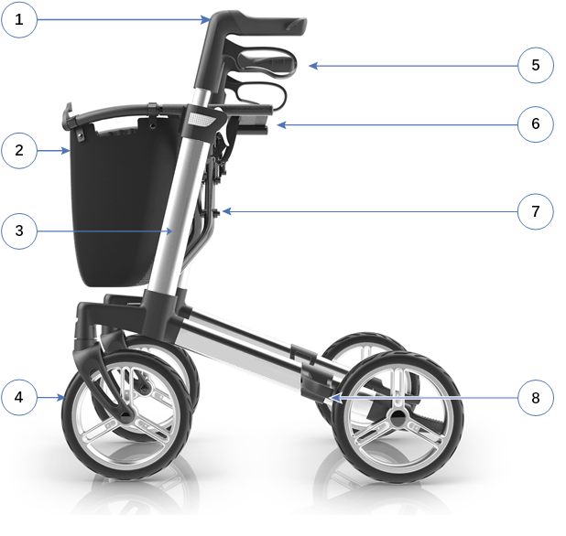

- Handgrip
- Shopping bag
- Frame
- Wheels (4x)
- Brake lever
- Seat
- Frame cross
- Brake

Upon delivery
Unpack your product and verify if the delivery is complete. Following items should be included:
- Rollator frame with seat, 4 wheels, 2 brake systems and 2 adjustable handgrips
- Shopping basket
- Backrest belt
- Manual
- Installation tools include 4# hex key and 10# wrench
Verify your product for transport damage. If you find any damages after delivery, contact the transporter.

Intended use
Indications and contraindications: The rollator is meant as support of the leg function during walking. Do not use the rollator if you have other physical limitations that may cause unsafe use of your rollator, like a weak arm, balance disorders, impaired vision, limb loss,...

The rollator is designed and produced solely to be used as walking aid for one person with a maximum weight of 130 kg. The rollator will compensate the lack of adequate support by the legs by leaning on, or moving with, the rollator with usage of the upper limbs or chest. The rollator will provide better stability, support and safety during walking.

It is not intended for transport of goods and/or more people than the user.

The rollator can be used indoor and outdoor. It should only be used on surfaces where all four wheels are touching the ground. Do not use the rollator on rocky, bumpy or sandy terrain, or places with a steep inclination. The rollator may become unstable. Look for flat, stable areas, and bevelled kerbs to walk with your rollator.

Please check all technical details and limits of your rollator in “7. Specifications”.
.
The warranty on this product is based on normal use and maintenance as described in this manual. Damage to your product caused by improper use or lack of maintenance will cause the warranty to lapse.

Safety instructions

WARNING – Please read and follow the instructions in this manual. Otherwise you may get injured, or your rollator may get damaged.

- Check that no stones or other objects block the wheels of the rollator.
- Make sure that both brake levers are in parking mode before you use the rollator as aid to stand up. When you are standing comfortable and stable, you can unlock the parking brakes.
- While walking, keep both hands on the handgrips.
- Be aware that some parts of your rollator may get very hot or cold due to ambient temperature, solar radiation, heating devices, etc. Be careful when touching.
- Before every use, check that the handgrips are firmly secured, see “4.1 Adjusting height.”
- Do not hold the handgrips with wet hands. If you do so, you can lose your grip and lose your balance.
- Do not proceed with your rollator into traffic. Always stay on the pavement.
- Take note of the instructions for care and service. The manufacturer is not liable for damage caused by improper servicing / care.

ATTENTION – Be aware that your rollator may interfere with some types of anti- theft systems, depending on the settings used. This may cause the shop's alarm to go off.

Shipping and storage
The shipping and storage of the rollator should happen according to the technical specifications in “7. Specifications“ Make sure that the rollator is stored dry.

Provide sufficient covering or packaging to protect the rollator from rust and foreign bodies (e.g. salt water, sea air, sand, dust).

Make sure no objects are stored on or against the rollator to prevent damage.

4.1 Adjusting height

WARNING – Don’t pull the handgrips too high to prevent damage to the brake cable. Don’t exceed the maximum height adjustment of the handgrips, your rollator will not be stable anymore.

ATTENTION – Due to ergonomically as well as safety reasons it is important that the height of the handles are adjusted correctly. The correct adjustment of the handles is very individual. A rule of thumb is that the handles should be level with your wrist when standing in an upright position.

- Put your rollator in parking mode, see figure 3.1.
- Pull and hold adjustment button, see figure 3.2.
- Hold the button and adjust the height of handgrip by raising or lowering it, see figure 3.3.
- Release button to lock the height adjustment. Pull the handgrip up and push it down to check of it is locked, see figure 3.4.
- Adjust the other handgrip in the same way.
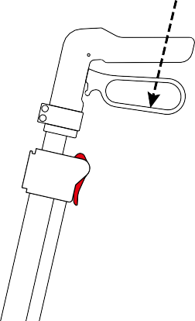
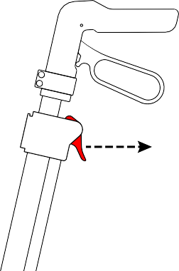
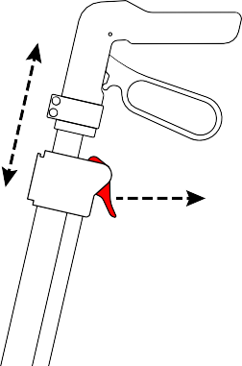
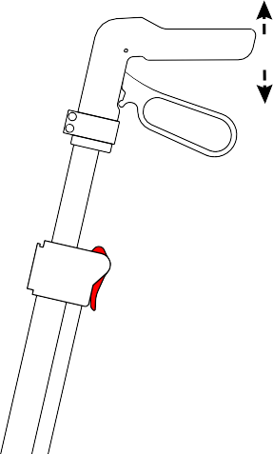
- Check that both handgrips are set on the same height mark.
1
Press
2

Pull
3

Adjust

Hold
4
Check

Release

Figure 3. Adjusting height

Unfolding and folding

WARNING – Keep fingers, buckle and clothes away from the frame cross.

WARNING – For your safety, please check that the rollator is completely open and that the frame is locked

Unfolding
- To unfold the rollator, simply pull the handles outwards, see figure 4.
- Push downwards on the outer rails of the seat in one swift motion, until you hear a significant click from the locking mechanism. locked; a click can be heard during locking.
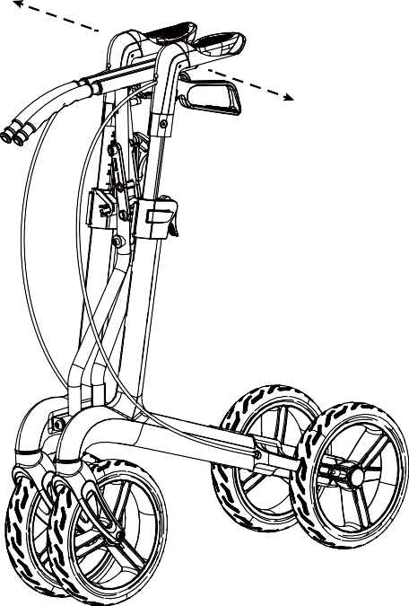
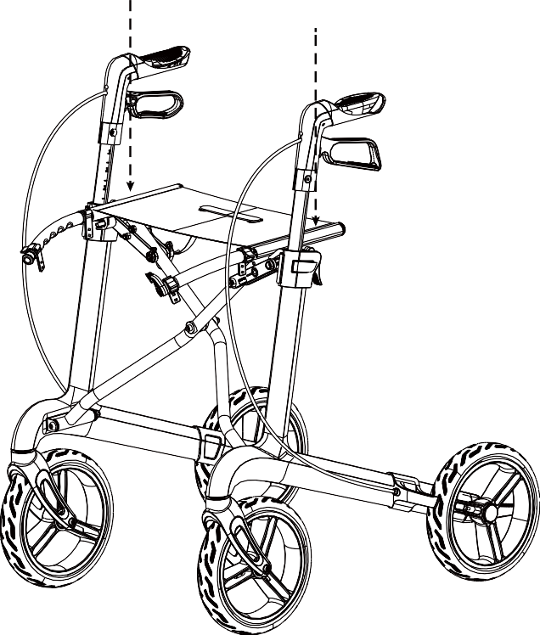
Figure 4. Unfolding rollator
ATTENTION – Make sure that the handgrips are fully upright before spreading the seat. If not, the frame cannot be opened completely. If this is the case, pull the seat up again to make the frame close and repeat step 1 and 2.

Folding
- Lift the seat by the nylon tape in the centre to open the lock catch.
- To ensure that the rollator is completely folded, push the handles toward each other.

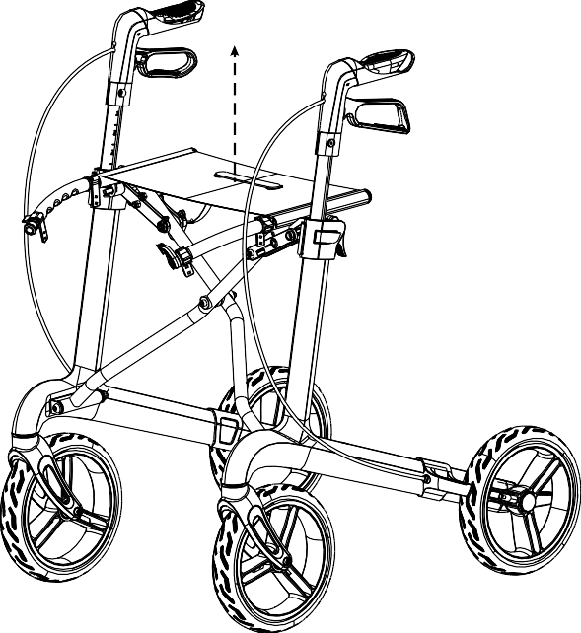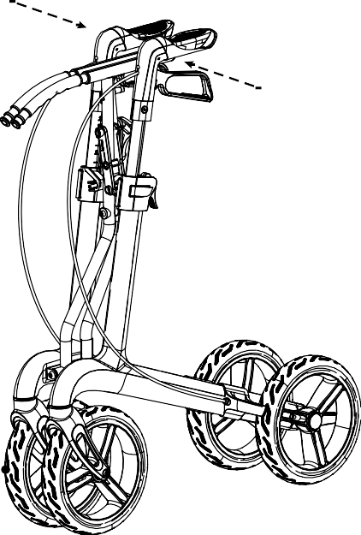

Brake system
Figure 5. Folding rollator

The rollator is equipped with brakes, operated by two brake levers. The brake levers can be used in two braking modes: stopping brakes and parking brakes.

WARNING – Check the working of the brakes to ensure your safety. The condition of the braking system is influenced by wear, oil and other contamination of the rear wheels and braking mechanism.

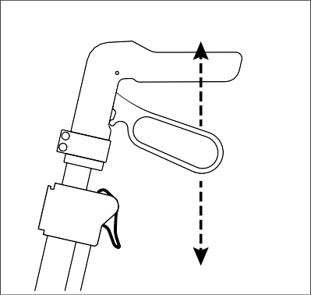
- To use the stopping brakes, pull both brake levers upwards [D]. To stop braking, release the brake levers.
D
P

- To use the parking brakes, push both brake levers downwards in locked position [P]. Always use both parking brakes simultaneously. To end the parking mode, pull both brake levers simultaneously upwards.

Backrest belt
Before using the seat:
- Make sure that backrest belt is well secured to the frame.
- Check that all screws, bolts and nuts of belt are well tightened.

Shopping bag

Figure 6. Brake system

The maximum carrying weight of the shopping bag can be found in "7.Specifications". The shopping bag is meant to be mounted on the hooks below the seat. For this, the bag is equipped with two loops, one at each side of the bag.

WARNING – Do not overload the shopping bag.

Kerb lifter
It is equipped with a kerb lifter that makes it easier to get over smaller obstacles like kerbs and low steps. This is particularly helpful if heavy objects are transported in a front-mounted basket or bag.
- Make sure you are standing stable while holding both handgrips.
- Use one foot and push on tipping lever to lift the front wheels.
- Keep the rollator in that position with the handgrips and move slowly forward until the front wheels are on the kerb.
- Now lift the handgrips and move forward to place the rear wheels on the kerb.
- When the rollator is standing stable, you can take the kerb yourself.

WARNING – Be aware that the stability of rollator changes when it is reclined. Be cautious and try to bypass rather than climb high obstacles.

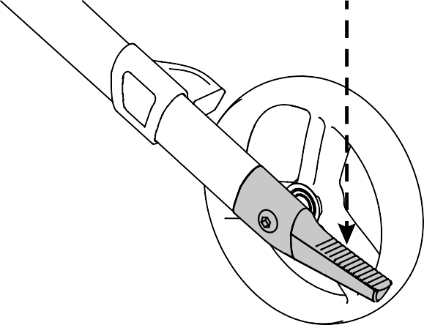
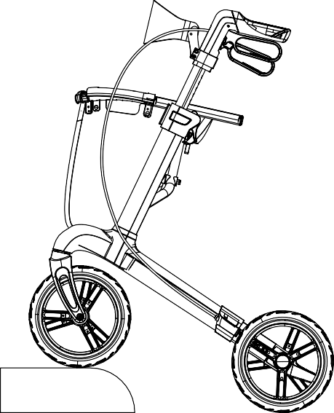

Sitting down, standing up and walking
Figure 7. Kerb lifter

WARNING – Make sure that both brake levers are in parking position before sitting down, see “5.2 Brake system". Keep the brake levers in this position until you start walking again. Keep your feet between the rear wheels.

- Push both brake levers down to parking position.
- While leaning on the handgrips, turn around and sit down on the seat.
- To stand up again, lean on the handgrips and turn around.
- Pull both brake levers up and use the running brakes.
- Release the brake levers and step forward with the rollator close to your body.

ATTENTION – Rollator should be regularly maintained by removing dust and dirt. Pay special attention to keeping the brakes clean to ensure that they always work as intended.

Cleaning
All surfaces can be cleaned with a textile cloth and clean water, if necessary with a little non-abrasive detergent. Wipe with a dry cloth afterwards. Do not use paper towels as these can scratch the surfaces.

WARNING – Disinfections may only be undertaken by trained persons. Consult your specialist dealer.

Disinfection
Use a soft, damp cloth and lukewarm water with a mild household disinfectant to clean the rollator.

Inspection / Service / Repairs
The expected service life of your rollator is 5 years. The lifespan is influenced by use, storage, maintenance, service and cleaning. Before you resume use of the rollator, it should be inspected on following points:
- Completeness.
- Folding mechanism: functioning well.
- Bolts and nuts: tightly fastened.
- Brakes: functioning well.
- Wheels (stability, tracking, fixing screws).

In case of regular contact with wires, hair or other residues, the wheels may get blocked. Check regularly that the wheels rotate freely and that they are in good condition.
- Frame (deformation, stability, connections).
- Handgrips (safe locking of height adjustment system, good support of handgrips).
- Seat (wear or damage).

The main materials of Spirit X3 and X4 are aluminum alloy and carbon fiber respectively. We recommend to have your rollator inspected at least once a year, but the service frequency depends on the frequency and intensity of use. Consult your specialist dealer to make an agreement on service frequency.

Repairs and replacements may only be undertaken by trained persons, and only genuine replacement parts of Intco should be used. Do not hesitate to use the services offered by your specialist dealer. He/ she will be glad to assist you regarding any service and repairs.

Reuse
Before each reuse, have the rollator disinfected, inspected and serviced according to the instructions in "6.2 Disinfection and 6.3 Inspection / Service / Repairs".

Disposal at end of life
At end of life, you need to dispose your rollator according to the local environmental legislation. The best way to do so, is to disassemble the rollator to facilitate the transport of recyclable parts.



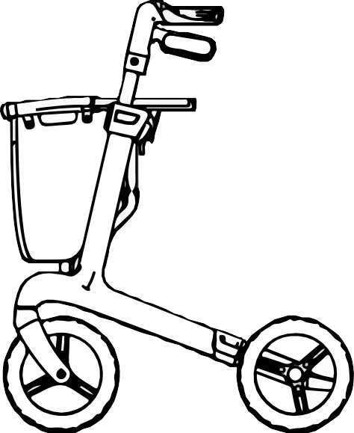


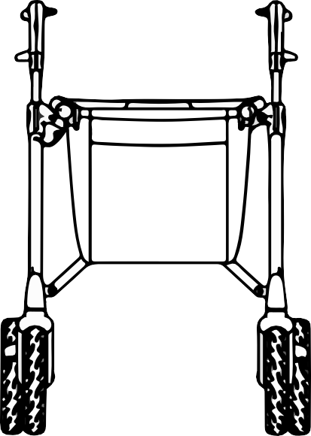
WARNING – Be aware of the correct settings and limits of use like described in this manual to avoid the risk of unsafe use.
C

F

G
E
D
A
B

Model | Spirit X3 |  | Spirit X4
Material | Aluminium alloy |  | Carbon fiber
Maximum user weight | 130kg
Recommended user height | 150-170cm | 170-195cm | 150-170cm | 170-195cm
Maximum load capacity in basket | 5kg
Total length A | 72cm
Total width B | 59cm |  | 60.5cm
Total weight | 7.2kg | 7.4kg | 6.7kg | 6.9kg
Total weight without  basket and backrest | 6.7kg | 6.9kg | 6.2kg | 6.4kg
Width between centre C  of push handles | 47.5cm
Seat height D | 56cm | 62cm | 58cm | 64cm
Total height E | 70-83cm | 75-95cm | 71-84cm | 77-96cm
Total height folded | 77cm | 81cm | 78.5cm | 82.5cm
Total length folded | 72cm
Total width folded | 22cm |  | 23cm
Diameter front wheels F | 20 x 3cm |  | 23 × 4.2cm
Diameter rear wheels G | 20 x 3cm |  | 23 × 4.2cm
Turning radius | 84cm
Storage temperature | +5° C - +41° C
Storage humidity | 30% - 70%
We reserve the right to introduce technical changes.
Measurement tolerance +/- 15 mm / 1,5 kg / 1,5° .

- Should a part or parts of the product require repair or replacement as a result of a manufacturing and/or material fault within 12 months, then the affected part or parts will be repaired or replaced free of charge. The warranty will only cover manufacturing defects.

- To enforce the warranty, please contact specialist dealer with the exact details of the nature of the difficulty. The product must be repaired by a Intco Medical designated Customer Service agent, (dealer).

- For parts, which have been repaired or exchanged within the scope of this warranty, we provide a warranty in accordance with these warranty conditions for the remaining warranty period for the product in accordance with point 1).

- For original spare parts which have been fitted at the customer’s expense, these will have a 12 months guarantee, (following the fitting), in accordance with these warranty conditions.

- Claims from this warranty shall not arise, if a repair or replacement of a product or a part is required for the following reasons:
    - Normal wear and tear, which include but is not limited to the following parts where fitted; handgrips, brakes, seat/back, tyres, wheels, etc.
    - Any overloading of the product, please check the specifications for maximum user weight.
    - The product or part has not been maintained or serviced in accordance with the manufacturers’ recommendations as shown in the user instructions and/or the service instructions.
    - Accessories have been used which are not specified as original accessories.
    - The product or part having been damaged by neglect, accident or improper use.
    - Changes/modifications have been made to the product or parts, which deviate from the manufacturer’s specifications.
    - Repairs have been carried out, before our Customer Service has been informed of the circumstances.
- This guarantee is subject to the law of the country in which the product was purchased from Intco Medical.

* Means the Intco Medical facility from which the product was purchased.

Your Health Intco Protects

Stock Symbol : 300677
Doc. No. : YK/UM-Spirit-001 Version: A/1
Manufacturer : Jiangsu Intco Medical Products Co.,Ltd.

Address: Tel :
Fax : Web : Email :
NO.77 Yandunshan Road, Dagang Zhenjiang, Jiangsu, 212132 China. 0086-511-83174088
0086-511-83174188
www.intcowheelchair.com intcosales@intco.com

Revision Date : 01/04/2022

